**Python Django Food Delivery App**

Food Ordering System in Python Django with Source Code

<https://codeastro.com/food-ordering-system-in-python-django-with-source-code/>

Admin Panel, Food Menu and Order Management

On the other hand, the user can access the Django administrator panel by providing admin credentials. The Django administrator panel contains all the management sides of the system. It includes management of food menu, user, and orders. The administrator can simply add more food menus by providing details such as name, description, price, and GIF attachment to it. Similarly, the user can check the customer order section to list all the orders. Here, the admin can simply check on the delivered radio button to mark it as delivered. Or also, the admin can log in to the system and check the orders section to list out all the orders. It displays order date, order items, customer’s name with order status. The admin can simply click on the order list to mark it as delivered. Rest all the things can be under the Django admin panel.

Last but not least, a clean and simple dashboard is presented with various color combinations for greater user experience while using this Online Food Ordering System Project in Python Django Framework. For its UI elements, a free open-source CSS framework; Bootstrap is on board with some Vanilla CSS too. Presenting a new Food Order Management System Project in Python Django which includes an admin panel with a user that contains all the essential features to follow up, and a knowledgeable resource for learning purposes.

Available Features:

* Customer Panel
* Admin Panel
* View Food Menu
* Place Order
* Add to Cart System
* List Orders
* Manage Food Menu
* Manage Food Orders
* Customer Management

<https://github.com/shyam999/Hot-Food>

Fully open-source online food delivery website built using Python, Django web framework, Bootstrap4, Vanilla Javascript, and more...

Free Download Online Food Ordering System Project in Python with source code, 2020-12-02

<https://www.kashipara.com/project/python/4689/online-food-ordering-system>

**Online Food Ordering System project is a web application which is developed in Python platform**. This Python project with tutorial and guide for developing a code. Online Food Ordering System is a **open source** you can **Download zip** and edit as per you need. If you want more [**latest Python projects here**](https://www.kashipara.com/project/category/latest_python-project-source-code_12). This is simple and basic level small project for learning purpose. Also you can modified this system as per your requriments and develop a perfect advance level project. Zip file containing the **source code** that can be extracted and then imported into Any. This Source code for BE, BTech, MCA, BCA, Engineering, Bs.CS, IT, Software Engineering final year students can submit in college. This script developed by Suraj Ghosh. This web application 100% working smooth without any bug. It is developed using **Python, HTML, CSS etc.** and Database Database is automatically Imported.. This software code helpful in **academic projects** for final year students. We have a great collection of [**Python projects**](https://www.kashipara.com/project/python-project_12).

Document and Reports information

This **doucment** file contains project Synopsis, Reports, and various diagrams. Also abstract pdf file inside zip so that document link below the page. [**Class Diagrams**](https://www.kashipara.com/page/diagram/project-class-diagram.php), [**Use Case Diagrams**](https://www.kashipara.com/page/diagram/project-use-case-diagram.php), [**Entity–relationship(ER) Diagrams**](https://www.kashipara.com/page/diagram/project-er-diagram.php), **Data flow diagram(DFD)**, [**Sequence diagram**](https://www.kashipara.com/page/diagram/project-sequence-diagram.php) and software requirements specification (SRS) in report file. Complete ready made open source code free of cost download. You can find [**Top Downloaded** Python projects here](https://www.kashipara.com/project/category/download_python-project-source-code_12).

Must have features your restaurant app needs

<https://www.peerbits.com/blog/restaurant-mobile-app-features.html>

What Are the Different Interfaces of a Food Delivery App?

<https://www.sparxitsolutions.com/blog/food-delivery-app/>

Building a Food Delivery Web App With Django and Python 3: Part 1 Setup, Index and About Pages

<https://www.youtube.com/watch?v=msmtduZfAHo&list=PLPSM8rIid1a0qiCpbfujex5lZoXr2SRFC>

In this video, we are going to start a new project. We are going to build a food delivery app. This application will have a customer side where orders can be placed and a restaurant side where those orders can be fulfilled and completed. In this first video we will set up the project and we will create an index page and an about page.

legionscript/deliver <https://github.com/legionscript/deliver/tree/master>

Building a Food Delivery App With Django and Python 3: Part 2 Building the Ordering System Part 1 <https://legionscript.medium.com/building-a-food-delivery-app-with-django-and-python-3-part-2-building-the-ordering-system-part-1-902fb69fdc88>

In this tutorial we are going to begin to build the ordering system for our food delivery web application. This will involve a lot of different details to get it functional so we will break it up into 2 different tutorials. In this tutorial we will set up the form to select menu items and submit them. After submitting, we will show a order summary with a total price. That will give us a basic version working that we can build off of next time.

Building a Food Delivery App With Django and Python 3: Part 3 Building the Ordering System Part 2 <https://legionscript.medium.com/building-a-food-delivery-app-with-django-and-python-3-part-3-building-the-ordering-system-part-2-db2a002403b5>

* Video Tutorial
* Code on Github

In this video we are going to finish our ordering system by adding some fields for the name, email, and address. We will add a modal asking the user to confirm their order before submitting as well. Finally, we will add a feature to send a confirmation email to the user once the order is submitted. This will give us much more functionality for the ordering system that will make it more user friendly as well as get some more important details that we didnt’ get last time.

Python Code For Food Ordering System

<https://itsourcecode.com/free-projects/python-projects/python-code-for-food-ordering-system/>

* Step 1: Create a project name.

First open Pycharm IDE and then create a “project name” after creating a project name click the “create” button.

* Step 2: Create a python file.

Second after creating a project name, “right click” your project name and then click “new” after that click the “python file“.

* Step 3: Name your python file.

Third after creating a python file, Name your python file after that click “enter“.

* Step 4: The actual code.

You are free to copy the code given below and download the full source code below.

Online Food Ordering System using Django with Source Code

<https://itsourcecode.com/free-projects/python-projects/online-food-ordering-system-using-django-with-source-code/>

**Features of Online Food Ordering System using Django**

Online Food Ordering System using Django with Source Code Features for Admin Side.

* **Dashboard** – For the admin dashboard, you will be able to all the basic access in the whole system. Such as cart items orders, items, users and categories.
* **Manage Items**– The admin has access to the item management information system. He can add, update and delete the items.
* **Manage Orders** – As the main functions of the admin, the admin can reject or accept from the customers on a case to case basis.
* **Manage Categories** – For the categories, the admin has the features of managing the category. The example category used in this system is best selling foods, spicy, and new foods.
* **Manage Users** – The admin can manage the user’s account. Admin can add, update and delete users in the system.
* **Login and Logout** – By default one of the security features of this system is the secure login and logout system.

**For Frontend Features of this Online Food Ordering System using Django**

Basically, the frontend side of the system refers to the main website of the whole system.

The frontend of this **Online Food Ordering System using Django** has these basic features of the website.

* **Home Page** – On the home page, you can see directly the list of foods for sale, login, logout, .
* **Viewing Products** – by default on the frontend, the customer can automatically view all the foods, the price and description of foods.
* **Checkout Order**– The customer can checkout order in the frontend that can confirmed by the admin in the backend.
* **Login and Logout –**The customer need to login in the system before they can add to cart their orders and they can also logout after they finish their order.
* **Sign up –** the customer need to register or sign up first before they can login into the system.
* **Add to Cart**– One of the features of this system is that, wherein the customer can temporarily add their order in the add to cart.

Food Delivery Management Simulation

<https://github.com/saksham-koul/Food-Delivery-Management-Simulation>The simulation project “Food Delivery Management System” is an attempt to model the food delivery system that is prevalent nowadays through online applications like Swiggy, Zomato, Uber Eats, etc. The project is visualised from a manager’s/ application’s perspective, who/ which has to deal with customer orders for different associated restaurants. The objective of the project is to estimate the order delivery time given the number of employees (chefs/ delivery executives) in/ near the restaurant, which can then be relayed to the customer.

Predict food delivery time using machine learning in Python

<https://www.codespeedy.com/predict-food-delivery-time-using-machine-learning-in-python/>

**Step-1 Importing required libraries**

**import** pandas **as** pd

**import** numpy **as** np

**import** matplotlib.pyplot **as** plt

**import** seaborn **as** sns

**from** *sklearn.ensemble* **import** RandomForestClassifier

**from** *sklearn.preprocessing* **import** LabelEncoder

**from** *sklearn.metrics* **import** accuracy_score

**from** *sklearn.model_selection* **import** train_test_split

**Step-2 Reading and transforming the data**

train_data=pd.read_excel('Data_Train.xlsx')

test_data=pd.read_excel('Data_Test.xlsx')

sample_data=pd.read_excel('Sample_Submission.xlsx')

train_data.head()

**Conclusion**

Use of Model with help of Python using Machine Learning for

* In-time delivery
* Predict food deliver time

Predict & Optimize Food Delivery Time Using Machine Learning & Analytics, 25 Aug 2021

<https://www.rishabhsoft.com/blog/optimize-food-delivery-time-with-machine-learning-analytics>

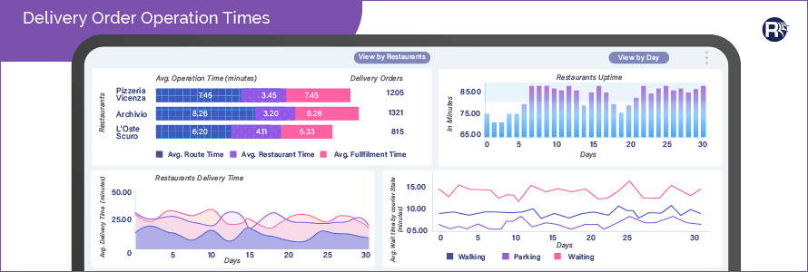

Impact of AI in Online Food Delivery System, Mar 3, 2021

<https://medium.com/tech-break/impact-of-ai-in-online-food-delivery-system-5c65a28aedae>

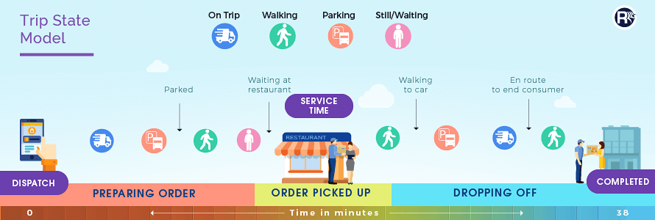

How Deliveroo uses machine learning to power food delivery

<https://outsideinsight.com/insights/how-deliveroo-uses-machine-learning-to-power-food-delivery/>

**How data drives decisions at Deliveroo**

**1**Informs strategic decisions from the top down

**2**Fuels machine-learning models

**3**Enables real time operational monitoring



Food preparation

It provides chefs with information on estimated preparation time of food, to optimise preparation and cooking speed, ensuring shorter lead times from kitchen to customer



Kitchen bottlenecks

It provides chefs and restaurant managers with a real-time kitchen overview dashboard, identifying potential bottlenecks



Buying efficiency

It provides restaurants with information so they can effectively manage their purchasing operations by predicting weekly order quantities and ingredient requirements

Food Delivery Efficiency Increased by 10% Thanks to Machine Learning

<https://stermedia.ai/food-delivery-efficiency-increased-by-10-thanks-to-machine-learning/>

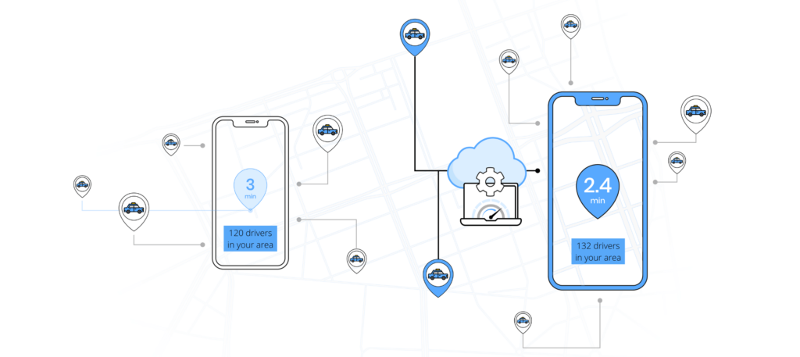

Machine Learning and AI in Food Industry: Solutions and Potential

<https://spd.group/machine-learning/machine-learning-and-ai-in-food-industry/>

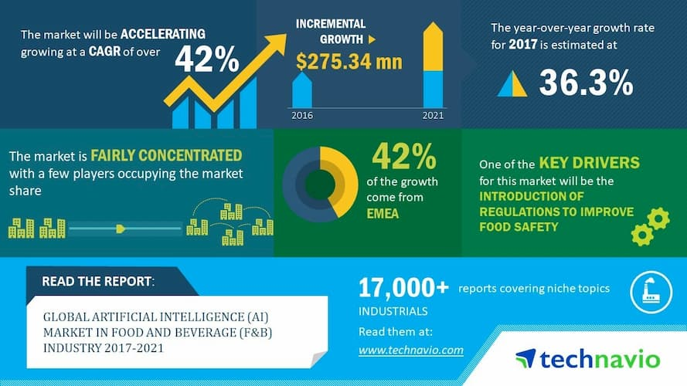

How Uber Eats Uses Machine Learning to Estimate Delivery Times, 19 Jul 2019

<https://thenewstack.io/how-uber-eats-uses-machine-learning-to-estimate-delivery-times/\>

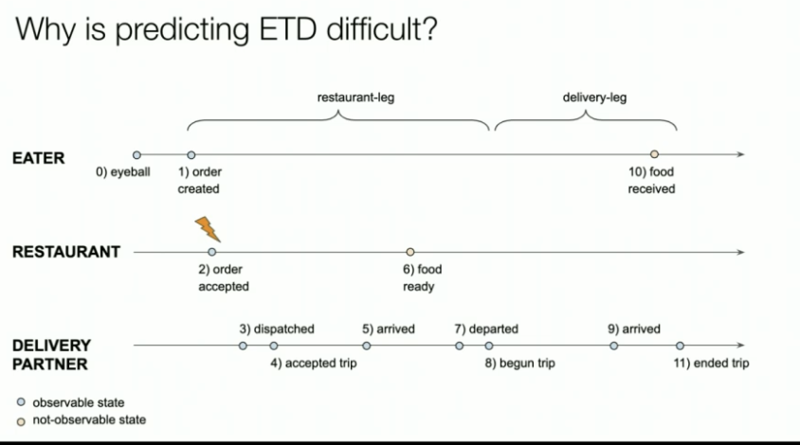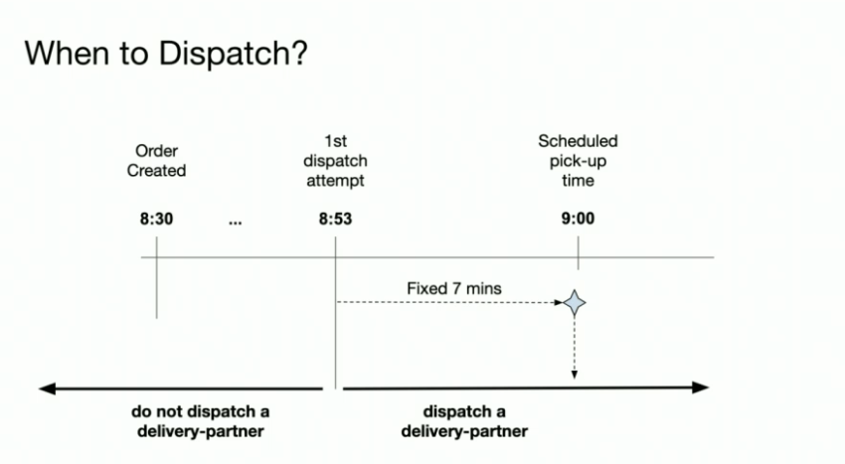

Why Online Food Delivery Companies Are Betting Big on AI and ML

<https://tweakyourbiz.com/business/technology-trends/online-food-delivery>

An Introduction to Food Delivery Time Prediction

<https://towardsdatascience.com/is-the-food-here-yet-f13a7bb0cd20>

A common metric that we can use to get a quick idea of our performance is the Mean Absolute Error (MAE). This tells us the average of the difference between our delivery time estimates and the actual delivery time. Going further, we can define two more domain-specific metrics: Basically on-time (< 5 mins late). OK, we’re a little late (< 10 mins late)

Predicting Time to Cook, Arrive, and Deliver at Uber Eats

<https://www.infoq.com/articles/uber-eats-time-predictions/>

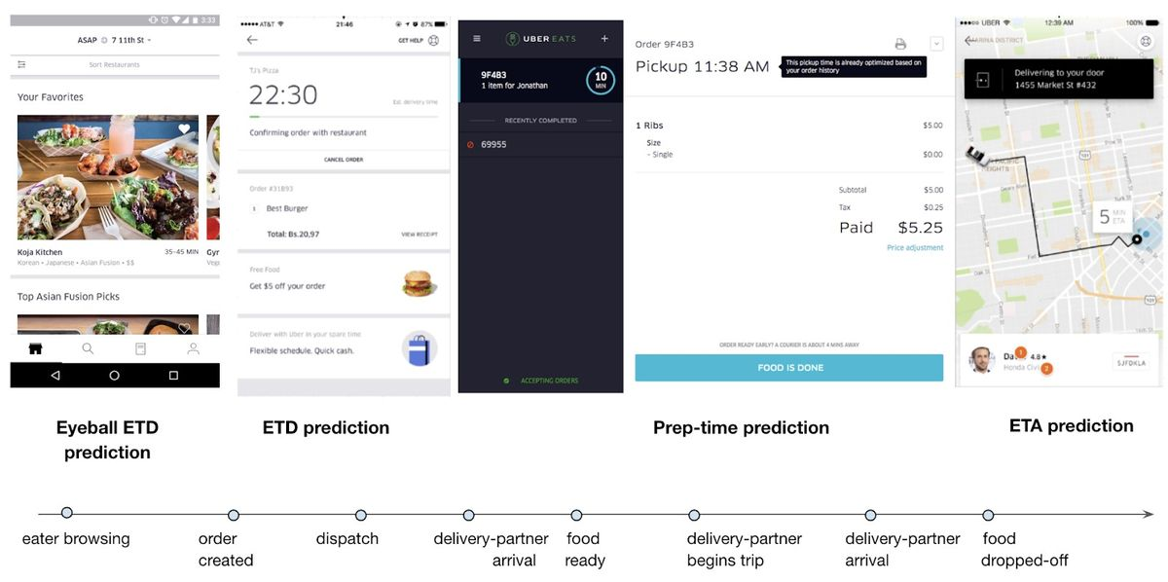

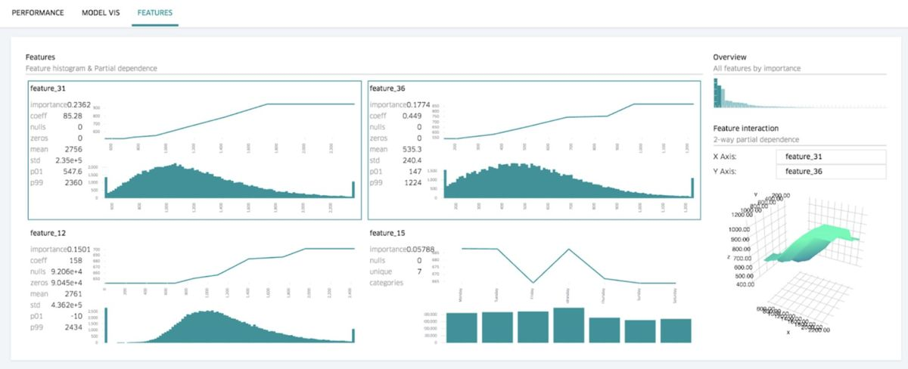

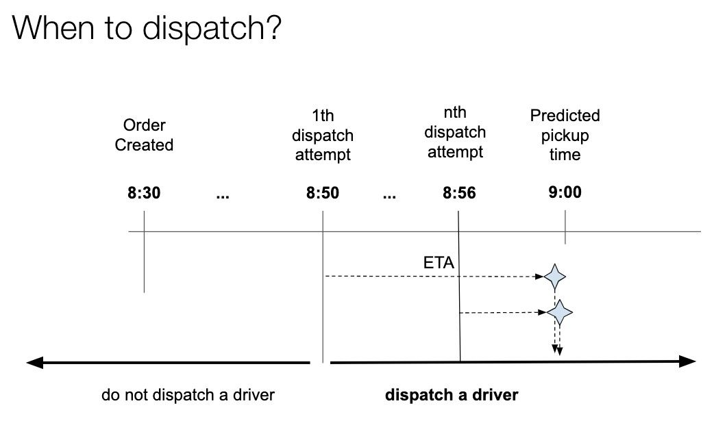

<https://www.conversenow.ai/>

AI Ordering for Restaurants

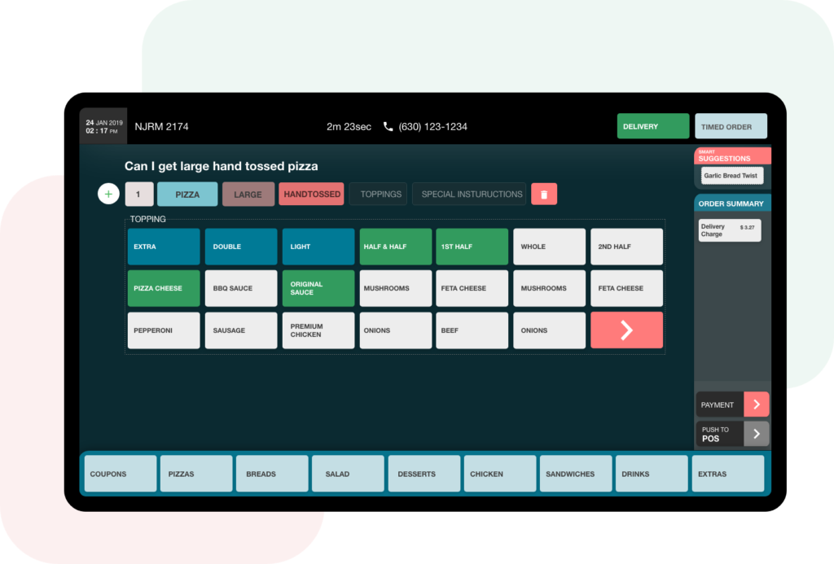

Doordash Engineering blog

<https://doordash.engineering/category/data-science-and-machine-learning/>

Using ML and Optimization to Solve DoorDash’s Dispatch Problem

<https://doordash.engineering/2021/08/17/using-ml-and-optimization-to-solve-doordashs-dispatch-problem/>

